Question 1: Dice Throw Problem
AIM
To write a program to find the number of ways to obtain a target score of 8 using 3 six-faced dice.
ALGORITHM
- Initialize dp[0] = 1.
- Process the dice one by one.
- For every possible current sum, try face values from 1 to 6.
- Add the number of ways to obtain the new sum.
- Repeat until all 3 dice are processed.
- Display dp[8] as the number of possible ways. 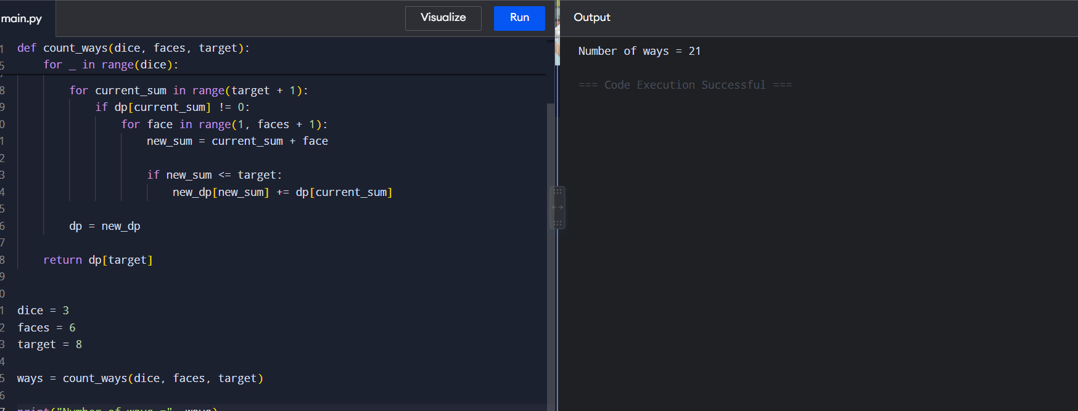
RESULT
Thus, the program successfully calculates the number of ways to obtain a score of 8.
Number of ways = 21

Question 2: Board Game Tournament
AIM
To write a program to determine the number of ways to obtain a total score of 7 using 2 six-faced dice.
ALGORITHM
- Initialize dp[0] = 1.
- Process each of the 2 dice.
- For every possible sum, try values from 1 to 6.
- Update the number of ways for each new sum.
- After processing both dice, obtain dp[7].
- Display the result. 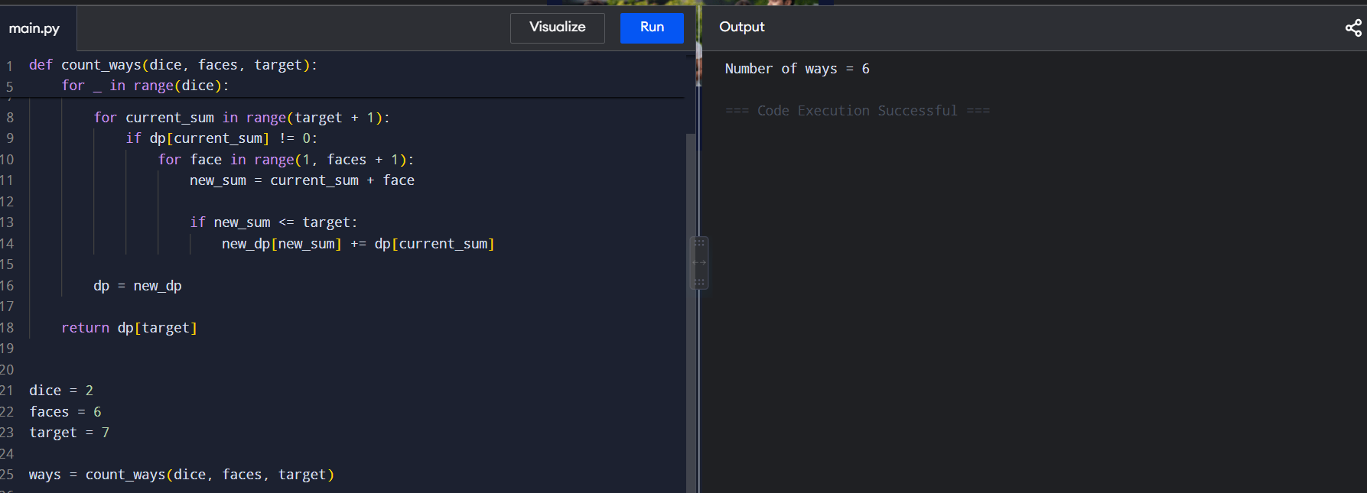
RESULT
Thus, the program successfully determines the number of combinations producing a score of 7.
Number of ways = 6

Question 3: Warehouse Robot Navigation
AIM
To write a program to determine the number of movement sequences that produce a total distance of 10 using 4 dice, each having 4 faces.
ALGORITHM
- Initialize dp[0] = 1.
- Process all 4 dice sequentially.
- For every current sum, consider face values from 1 to 4.
- Calculate the new sum.
- Update the corresponding number of ways.
- After processing all 4 dice, obtain dp[10].
- Display the number of valid movement sequences. 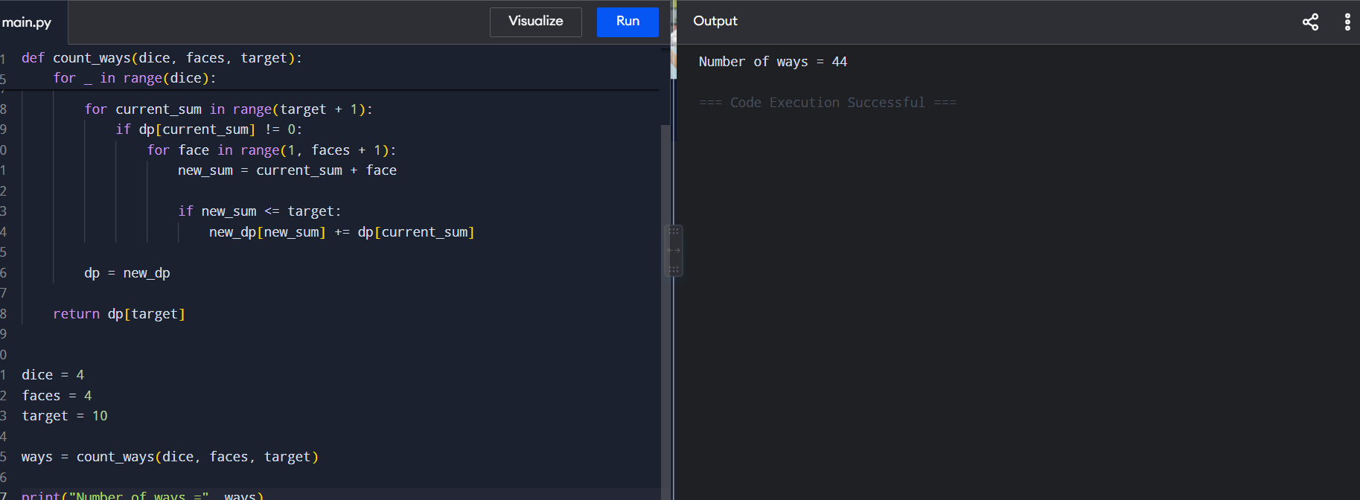
RESULT
Thus, the program successfully calculates the number of possible movement sequences.
Number of ways = 44

Question 4: Casino Reward Calculation
AIM
To write a program to calculate the number of ways to obtain exactly 12 points by rolling 3 six-faced dice.
ALGORITHM
- Initialize dp[0] = 1.
- Process each of the 3 dice.
- For each possible current sum, consider face values from 1 to 6.
- Update the number of ways for every possible new sum.
- After all dice are processed, access dp[12].
- Display the total number of winning combinations. 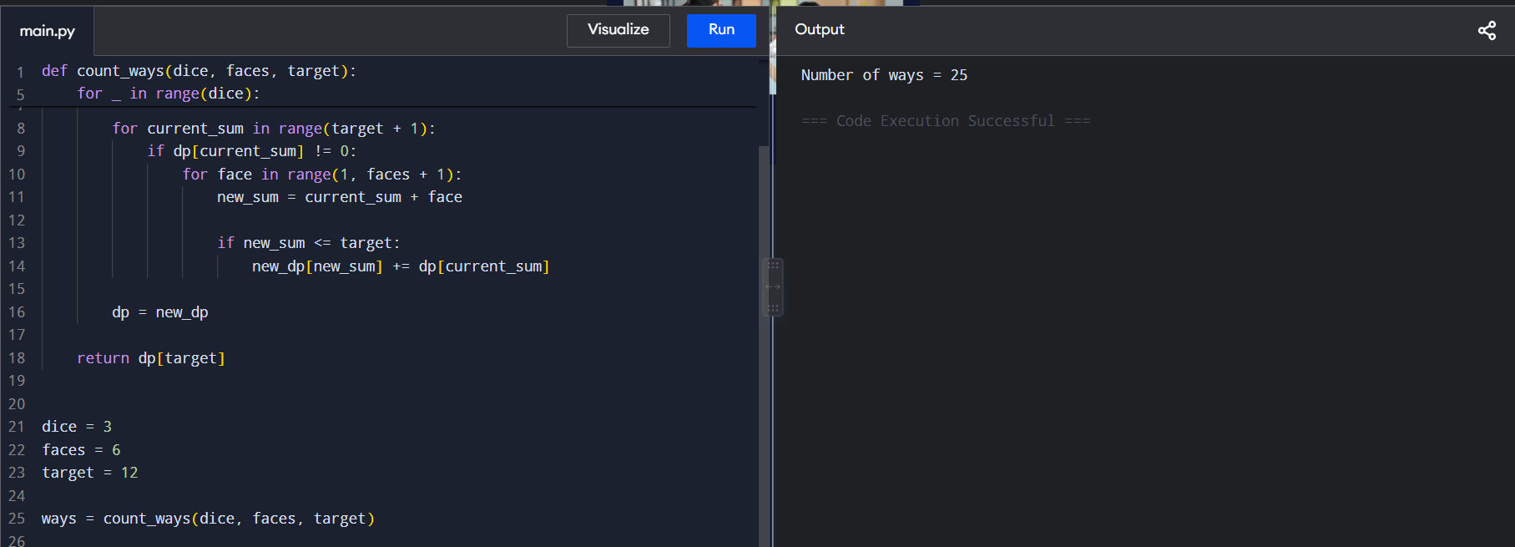
RESULT
Thus, the program successfully calculates the number of winning combinations.
Number of ways = 25

Question 5: Quiz Competition Scoring
AIM
To write a program to determine the number of ways to obtain a target score of 15 using 5 six-faced dice.
ALGORITHM
- Initialize dp[0] = 1.
- Process the 5 dice one at a time.
- For each current sum, try all face values from 1 to 6.
- Calculate the resulting sum.
- Update the number of ways to obtain that sum.
- Continue until all 5 dice are processed.
- Access dp[15].
- Display the number of valid scoring combinations. 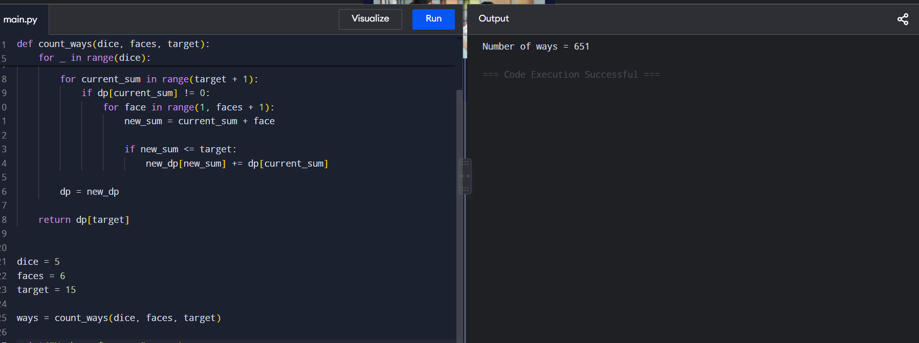
RESULT
Thus, the program successfully determines the number of valid scoring combinations.
Number of ways = 651

